Four mechanisms to provide the programmer the ability to create new data types and operations that type:
1. Structured data. languages have included features for creating complex data objects out of elementary data objects defined by the language designers. Arrays, lists, and sets to create homogeneous collections of objects. Records are a mechanism for creating nonhomogeneous collections of data objects.
2. Subprograms. Programmer could create subprograms that perform the functionality of a new type; correct use of the new type is the responsibility of the programmer with little automated support provided by the language.
3. Type declarations. The language includes the ability to define new types and operations on that type. The concept of abstract data types is available in languages like java
4. Inheritance. Concepts of object-oriented programming expand the ability of the programmer to create new types, build operations to use those types, have the programming language detect improper uses of type.

STRUCTURED DATA TYPES: Data structure is a data object that contains other data objects as its elements.
Structured Data Objects and Data Types:A data object that is constructed as aggregate of other data objects, called components, is a structured data object or data structure. Component may be elementary or it may be another data structure. Issues and concepts of data structures in programming languages are same as for elementary data objects and are treated. Bindings of data structures to values, names, and locations are important and more complex in this setting.
Specification of Data Structure Types: Attributes for specifying data structures:
1. Number of components. A data structure is of fixed size if number of components is invariant during its lifetime and of variable size if the number of components changes dynamically. Variable-size data structure types define operations that insert and delete components from structures. Arrays and records are common examples of fixed-size data structure types; stacks, lists, sets, tables, and files are examples of variable-size types. Variable-size data objects often use a pointer data type that allows fixed-size data objects to be linked together explicitly by the programmer.
2. Type of each component. A data structure is homogeneous if all its components are of the same type. It is heterogeneous if its components are of different types. Arrays, sets, and files are usually homogeneous records and lists are heterogeneous.
4. Names to be used for selecting components. A data structure type needs a selection mechanism for identifying individual components of data structure. Array, name of individual component may be integer subscript; for table or record, name may be programmer-defined identifier. Data structure types like stacks and files allow access to only a particular component (top or current component) at any time, but operations are provided to change the component that is currently accessible.
4. Maximum number of components. For variable-size data structure such as stack, maximum size for structure in terms of number of components may be specified.
5. Organization of the components.Simple linear sequence of components: Vectors (1D array), records, stacks, lists, and files are data structures with this organization. Array, record,and list are multidimensional forms:
Operations on Data Structures:Specification of domain and range of operations on data structure types are same manner as for elementary types.Some new classes of operations are of particular importance:
1. Component selection operations. Processing of data structures proceeds by retrieving each component of structure. Two types of selection operations access components of a data structure making them accessable for operation:
Random selection, in which an arbitrary component of the data structure is accessed,
Sequential selection, components are selected in a predetermined order.In vector, (F[4])
2. Whole-data structure operations. Operations take entire data structures as arguments and produce new data structures as results. Most languages provide a limited set of such whole-data structure operations (e.g., addition of two arrays, assignment of one record to another, or a union operation on sets). Languages such as Python(numpy package).
3. Insertion/deletion of components. Operations that change the number of components in a data structure have a impact on storage representations and management for data structures.
4. Creation/destruction of data structures. Operations that create and destroy data structures have a impact on management for data structures.
Selection/accessing of a component or data value in a data object should be distinguished from the related operation of referencing.

Implementation of Data Structure Types:The storage representation for data structure includes (1) storage for the components of the structure, (2) an optional descriptor that stores some or all of the attributes of the structure. Two basic representations are:
1. Sequential representation: data structure stored in single contiguous block of storage including descriptor and components.
2. Linked representation: data structure stored in several noncontiguous blocks of storage, with blocks linked together via pointers. A pointer from Block A to Block B, called a link, represented by storing the address of first location of Block B.
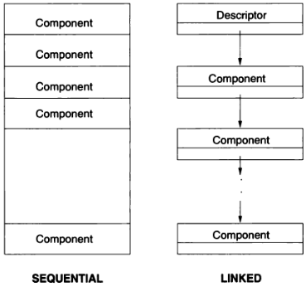
hardware lacks provisions for data structure descriptors, manipulation of linked representations, storage management for data structures, easy manipulation of external files. So, data structures and operations that work with data structures must be software simulated in the programming language's virtual computer implementation, in contrast to elementary data types, where direct hardware-supported storage
Implementation of Operations on Data Structures:Component selection is of primary importance in the implementation of most data structures. Efficiency of both random-selection and sequential-selection operations is needed.
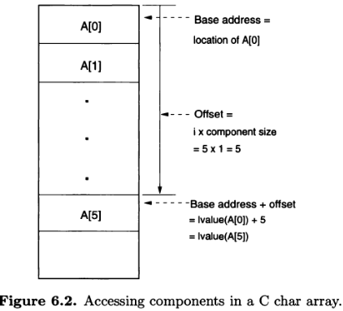
- Sequential representation. Random selection of a component often involves a base-address-plus-offset calculation using an accessing formula. The relative location of the selected component within the sequential block is called its offset. The starting location of the entire block is the base address. The accessing formula, given the name or subscript of the desired component (e.g., the integer subscripts of an array component), specifies how to compute the offset of component. Offset is then added to base address to get actual location in memory of selected component, Note that this calculation may be very efficient; if constant subscripts are used, then the translator can calculate the accessing formula during compile time and generate code to directly access the component. For a homogeneous structure such as an array that is stored sequentially, selection of a sequence of components from the structure is possible by these steps:
1. To select the first component of the sequence, use the base-address-plus-offset calculation described earlier.
2. To advance to next component in sequence, add size of the current component to the location of the current component.
- Linked representation. Random selection of a component from a linked structure involves a chain of pointers from the first block of storage in the structure to the desired component. For this selection algorithm, position of link pointer within each component block must be known. Selection of a sequence of components proceeds by selecting the first component and then following the link pointer from the current component to the next component for each subsequent selection.
Data structure representations are sometimes extended to include system-defined structures that allow efficient component selection.

Storage Management and Data Structures
lifetime of data object begins when binding of object to particular storage location is made, and ends when this binding of object to storage block is dissolved. Data structure of variable size, individual components of structure have their own lifetimes, which are determined by time at which they are created and inserted into structure and by the time at which they are deleted from the structure.
When data object is created ,access path to the data object is also created so that the data object can be accessed by operations in the program. Creation of access path is accomplished either through association of the data object with an identifier, its name or through storage of a pointer to the structure in other already accessible structure, Data object becomes a component of the older structure.
Additional access paths to it may be created to data Strucure (by passing it as argument to subprogram or creating new pointers to it). Access paths can destroyed in various ways (by assigning new value to pointer variable or by return from a subprogram), At any point during the lifetime of a data object, several access paths to it may exist.
Two central problems in storage management arise because to this:
1. Garbage. When all access paths to data object are destroyed but data object exists, the data object is garbage as it is no longer accessable. The binding of data object to storage location has not been broken, so storage is not available for reuse.
2. Dangling references. A dangling reference is an access path that continues to exist after the lifetime of the associated data object. The recovery of the storage block does not necessarily destroy the existing access paths to the block, and thus they may continue to exist as dangling references.
Dangling references are serious problem as they compromise the integrity of the entire run-time structure during program execution. Eg., an assignment to a nonexistent data object via a dangling reference can modify storage already allocated to another data object of an entirely different type (violating the security of the type-checking structure).
Garbage is less serious, but still troublesome, problem. Because storage is finite. Buildup of garbage can force the program to terminate prematurely because of insufficient memory in which to execute.
Declarations and Type Checking for Data Structures: Basic concepts and concerns of declarations and type checking for data structures are similar to those discussed for elementary data objects. Structures are more complex as there are more attributes to specify. Eg, C declaration float A [20]; at the beginning of a subprogram P specifies the following attributes of Array A:
1. Data type is an array.
2. Number of dimensions is one.
3. Number of components is 20.
4. Subscripts naming the rows are the integers from 0 to 19.
6. Data type of each component is float.
Declaration allows sequential storage representation and accessing formula for selecting any component A[I] of A to be determined at compile time. A is not created until entry to subprogram P at run time. Without the declaration, the attributes of A would have to be determined dynamically at run time, where component accessing would be much less efficient.
Type checking is more complex for data structures because component selection operations is taken into account. There are two main problems:
1. Existence of a selected component. The arguments to a selection operation may be of the right types, but the component designated may not exist in the data structure. For example, a subscripting operation that selects a component from an array may receive a subscript that is out of bounds for the particular array. This is not a type-checking problem provided that the selection operation fails by noting the error and raising an exception. If run-time type checking is disabled for efficiency and the exception is not raised, the result of a selection operation is almost always used immediately as an argument by some other operation. If the selection operation produces an incorrect 1-value, the effect is similar to type-checking error. The operation receiving the result is given an invalid argument (the location of a block of storage that may contain data of the
wrong type, executable code, etc.).
2. Type of a selected component. A selection sequence may define a complex path through a data structure to the desired component. Eg, in C: A[2][3].link-> item; selects content of the component named item in the record reached via pointer contained in the component named link of the record. To perform static type checking, it must be possible to determine at compile time the type of the component selected by any valid composite selector of this sort. As noted earlier, it cannot be assumed in general that the selected component exists when needed at run time. Instead, static type checking only guarantees that if the component does exist, then it is of the right type.

Vectors and Arrays: vector is data structure composed of a fixed number of components, same type organized in simple linear sequence. Component of vector is selected by giving its subscript, an integer (or enumeration value) indicating
the position of the component in the sequence. A vector is 1-D array or linear array.
2-D array, or matrix, has its components organized into a rectangular grid of rows and columns. Both a row and a column subscript are needed to select a component of a matrix. Multidimensional arrays of three or more dimensions.
Vectors: attributes of a vector:
1. Number of components: implicitly by giving a sequence of subscript ranges, one for each dimension.
2. Data type of each component, A single data type, because the components are all of the same type.
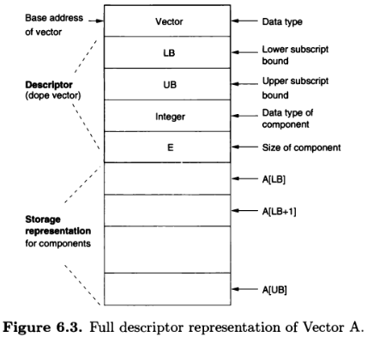
3. Subscript to be used to select each component, given as a range of integers, with the first integer designating the first component, the second designating the second component.
Eg. in C, float a[10];

Operations on vectors. Selects a component from a vector is called subscripting operation; written as vector name followed by the subscript of the component to be selected (e.g., V[2] or Class Aver age[Soph]).
Subscripting operation returns the 1-value or location of the relevant data object.
Other operations on vectors are to create, destroy vectors, assignment to components, operations to perform arithmetic
Addition of two vectors (add corresponding components, iff of same size). as vectors are of fixed size, insertion & deletion of components are not allowed;
Implementation. The homogeneity of components and fixed size of a vector make storage and accessing of individual components straight forward.
Homogeneity means size/structure of each component is the same, fixed size means number/position of each component of a vector are invariant throughout its lifetime. A sequential storage representation is used. A descriptor is included to store attributes of the vector, especially if all such information is not known until execution time. Upper and lower bounds of the subscript range, are commonly stored in the descriptor. The other attributes often are not stored in the descriptor at run time; they are needed only
during translation for type checking and for setting up the storage representation.

initial component, the Ith addressed by skipping I — 1 components.
E be size of each component, we skip (I — 1) x E memory locations.
LB be lower bound on the subscript range, then the number of such components to skip is I — LB, or (I— LB) x E memory
locations. If the first element of the vector begins at location α, we get the accessing formula for the 1-value of a vector component: lvalue(A[I]) = α+ (I- LB) x E
This can be rewritten as lvalue{A[I]) = (a - LB x E) + (/ x E)
Note that once storage for the vector is allocated, (α — LB x E) is a constant (call it K) and the accessing formula reduces to
lvalue(A[I]) =K + I x E
This makes vector accessing quite fast. as size of each component (E) is known at translation time, if the value of subscript I is also known to the translator (e.g., A[2]), then the entire accessing formula reduces to a compile-time value.
lvalue(A[I]) = α + I
at, lvalue{A[0\) = (a - LB x E) + (0 x E)
= {a-LBxE)
= K
K represents the address that the element 0 of the vector would occupy. as the zeroth element may not be part of the array (because array may have a lower bound greater than 0), this address is called the virtual origin (VO). Algorithm for building vectors and generating the accessing formula:
1. On creation of vector storage: Allocate storage for TV components of the vector of size E and descriptor of size D. (Allocate D + N x E memory locations.) Call a the address where the first vector element is stored.
2. Compute the virtual origin VO = a - LB x E.
On accessing a vector component: The 1-value of any component A[I] is computed as, lvalue(A[I]) = VO + I x E

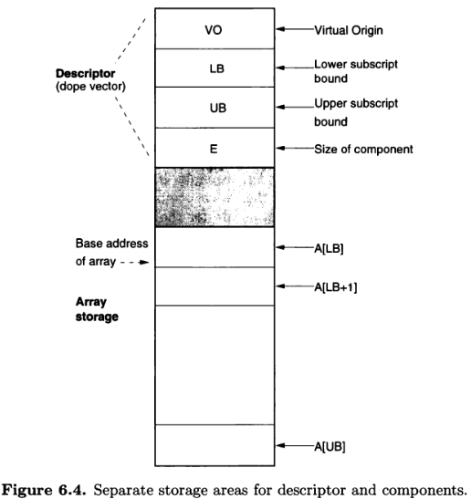
To check for a subscript range error, the test LB < I < UB
LB and UB must be present in the run-time descriptor.
If the virtual origin is stored in the array descriptor,then the actual array need not be contiguous with its descriptor.

Packed- and unpacked-storage representations. Accessing formula given earlier presumes that the size, E, of each component is an integral number of addressable storage units .
Eg, if basic unit of addressable storage in computer is word, then each component is presumed to fill one word, two words, and so on, appropriate for declared component type.
=> If the component type is Boolean/character, small part of word is required to store one component, and thus several components might be packed into a single word.
=> A packed-storage representation is one in which components of a vector are packed into storage sequentially without regard for placing each component at the beginning of an addressable word (or byte) of storage. A packed-storage representation allow substantial savings in the amount of storage required for a vector.
=> Unfortunately, access to component of a packed structure is more expensive because simple accessing formula above cannot be used. More complex series of calculations is required to access the memory word that contains the component.
So, vectors are often stored in unpacked form.
Multidimensional Arrays: a matrix composed of rows and columns of components is a 2-D array; a 3-D array is composed of planes of rows and columns; arrays of any number of dimensions may be constructed from arrays of fewer dimensions. The storage representation and accessing formula for vectors generalize readily to multidimensional arrays.
Syntax a subscript range for each dimension is required. Eg in Java int[][] arr = new arr[2][3] .Selection of component requires that one subscript be given for each dimension
Implementation. A matrix is implemented by considering it vector of vectors; a 3-D array is a vector whose elements are vectors of vectors, and so on. Note that all the subvectors must have the same number of elements of the same type.
=> Whether a matrix is viewed as a column of rows or a row of columns is important in some contexts. Most common is the column-of-rows structure in which the matrix is considered as a vector in which each element is a subvector representing one row of the original matrix. This representation is known as row-major order.
=> In general, array of any number of dimensions is organized in row-major order when the array is first divided into a vector of subvectors for each element in the range of the first subscript, then each of these subvectors is subdivided into subsubvectors for each element in the range of the second subscript, and so on.
=> Column-major order is the representation in which the matrix is treated as a single row of columns.
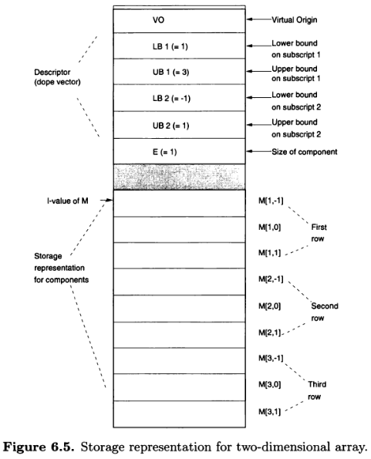
=> In matrix, store the data objects in first row (row-major order), followed by data objects in second row, and so on. Result is single sequential block of memory containing all the components of array in sequence. The descriptor for array is same as for a vector, except that upper and lower bound for subscript range of each dimension are needed.

The subscripting operation, l-value of A[I, J],
location of element A[I, J] is given by
lvalue(A[I, J]) = α + (I - LB1) x S + (J - LB2) x E
where, a = base address
S = length of a row = (UB2 - LB2 + l)xE
LB1 = lower bound on first subscript
LB2, UB2 = lower and upper bounds on the second subscript
Collecting constant terms, this simplifies to
S = (UB2 -LB2 + l) x E
VO = α-LB1 x S- LB2 x E
lvalue(A[I, J]) = VO + I x S + J x E

Similar to the vector case, E is the size of each component and S is the size of each
row of the matrix.
Note that VO, S, α, and E are fixed when the array is created and thus need be computed only once and stored. VO, as in the vector case, is the virtual origin and represents the location for A[0,0], if it would exist in the array. The worst-case computation necessary on each access then becomes => lvalue(A[I, J]) = VO + I x S + J x E

Slices
Specification. A slice is a substructure of an array that is an array.
Implementation. The use of descriptors permits an efficient implementation of a slice.

Associative Arrays
the name as the index. Because the sequence of names (strings of letters) is essentially infinite, there is no implied enumeration that is feasible. Instead, the set of names are used as the enumeration set; if a new name is added, this enumeration is increased. Such an array is called an associative array. In Perl,
%ClassList = ( "Michelle", 'A', "Doris", 'B\ "Michael", 'D' );
creates a three-element associative array. The first members of each pair are the keys, and the second members are the values.

Records: A data structure composed of a fixed number of components of different types is a record.
Specification. Both records and vectors are forms of fixed-length linear data structures, but records differ in two ways:
1. Components of records may be heterogeneous ( mixed data types) rather than homogeneous.
2. Components of records are named with symbolic names (identifiers), rather than indexed with subscripts.

The attributes of a record are seen in the prior declaration:
1. The number of components
2. The data type of each component
3. The selector used to name each component

The components of a record are often called fields, and the component names then are the field names. Records are sometimes called structures (C Language)
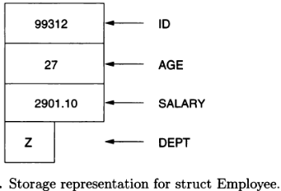
struct EmployeeType
{int ID;
int Age;
float SALARY;
char Dept;
} Employee;
Component selection operation on a record, as in the selection Employee.SALARY. This operation corresponds to the subscripting operation

Operations on entire records are usually few. Most commonly assignment of records of identical structure is provided.

Implementation. storage representation for a record consists of a single sequential block of memory in which the components are stored in sequence. Individual components need descriptors to indicate their data type etc, but ordinarily no run-time descriptor for the record is required.
Component selection is easily implemented because subscripts (field names) are known during translation rather than being computed during execution. The declaration for the record also allows the size of each component and its position within
the storage block to be determined during translation. As a result, the offset of any component may be computed during translation. The basic accessing formula used to compute the location of the Ith component is
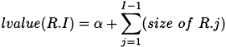

where α is the base address of the storage block representing R and R.j is the jth component. The summation is necessary because of the possibly differing sizes of each component. However, the summation may always be computed during translation to give the offset, K_{I}, for the Ith component, so that during execution only the base address for the storage block need be added: lvalue(R.I) = α + K_{I}
With some data types, storage must begin on specific address boundaries.
struct EmployeeDivision
{ char Division;
int IdNumber; } Employee

IdNumber must begin on a word boundary, and three bytes between Division and IdNumber are unused and are considered padding. The storage representation would be as if the following were declared:
struct EmployeeDivision
{char Division;
char UnusedPadding[3];
int IdNumber;
} Employee

The operation of assignment of an entire record to another of identical structure may be implemented as a simple copy of the contents of the storage block representing the first record into the storage block representing the second record.

Records and Arrays with Structured Components: Languages with arrays and records as basic data types, components can be intermixed with components of elementary types. like vector in which each component is a record is often useful, as in the C declaration => Vector of EmployType

struct EmployeeType
{int ID;
int Age;
float SALARY;
char Dept;
} Employee[500];

component is selected using a sequence of selection operations select component of vector, then component of record, Employee[S].SALARY.

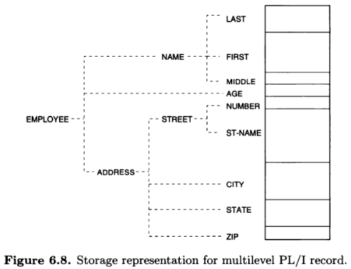
A record may have components that are arrays/other records, leading to records that have hierarchical structure consisting of top level of components, some of which may be arrays/records. Components of these second-level components may be arrays/records.
Implementation.
The storage representations for simple vectors and records
extend without change to vectors and records whose components are vectors or records.
A vector of records has the same storage representation as a vector of integers or any other elementary type, except
that the storage block representing a component in the larger block representing the vector is the storage block for a record. Thus, a vector of records is stored much as the vector of vectors, but with each row replaced by the storage
representation of a record.
Similarly, a record whose components are records (or vectors) retains the same sequential storage representation, but with each component represented by a subblock that may be the representation of an entire record.
Selection of components requires only a sequence of selections—starting from the base address of the complete structure and computing an offset to find the location of the first-level component, followed by computation of an offset from this base address to find the second-level component, and so on.

Variant Records
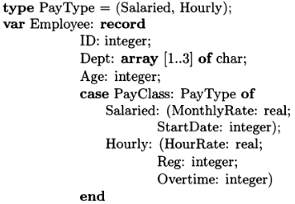
Eg, employee who may be paid either hourly or monthly. It may be useful to have a single record type that has several variants. Such a record ordinarily has one or more components that are common to all variants, and then each variant have other components with names and data types that are unique to that variant. For example, a record containing employee payroll information may have two variants: one for salaried employees paid by month and one for employees paid by hour.
Record always has components ID, Dept, Age, and PayClass. When PayClass = Salaried, record has the components Monthly Rate and Start Date, if the value of PayClass =Hourly, then it has HourRate, Reg, and Overtime. Selection operation for components is same as for ordinary record. Eg Employee.MonthlyRate
The component PayClass is called the tag (Pascal) because it serves to indicate which variant of the record exists at a given point during program execution.
For ordinary records, each component exists throughout the lifetime of the record, but in variant Record, the component may exist at one point during execution (when the tag component has a particular value), may later cease to exist (when the value of the tag changes to indicate a different variant), and later may reappear (if the tag changes back to its original value). This problem of selection of a nonexistent component of a variant record is similar to the subscript range error. The possible solutions:
1. Dynamic checking. The tag component may be checked at runtime to ensure that the component exists. If the tag has the proper value, then the component is accessed; if not, then it is a run-time error,
2. No checking. The language design may allow variant record definitions without an explicit tag component that may be checked at run time, so that selection of a component of a variant record is presumed to be valid

Record types with variants are also commonly known as union types because each variant may be considered as a separate class of record data object, and then the overall record type appears as the union of these sets of data objects. If there
is no designated tag field, then it is a free-union type; if there is, then it is a discriminated-union type. The term discriminated refers to the fact that it is possible (by checking the tag field) to discriminate the variant class to which each data object of the overall type belongs.

Implementation. During translation, the amount of storage allocated in the record for the largest possible variant. Each variant describes a different layout for the block in terms of number and types of components. As the block is large enough for the largest variant, there is space in the block for any one of the variants at a given time during program execution, but smaller variants may not use some of the allocated storage.
The layouts are determined during translation and are used to compute offsets for component selection. During execution, no special descriptor is needed for variant record because the tag component is considered just another component of the record.
Selection of component of variant is identical to selection of a component of an ordinary record, when no checking is to be done.
During translation, the offset of the selected component within the storage block is computed; during execution, the offset is added to the base address of the block to determine the location of the component.
If the component does not exist, this accessing calculation gives the location where the component would be stored if it did exist, An assignment to a component that does not exist, if unchecked, changes the contents of the location accessed(with possibly disastrous results).
If dynamic checking is provided for selection of components of variants, then at run time the base-address-plus-offset calculation to locate the component is the same, but first the value of the tag field must be checked to ensure that the tag
indicates that the proper variant currently exists.

Lists: A data structure composed of an ordered sequence of data structures is usually termed a list.
Specification and syntax. : Lists are similar to vectors in that they consist of an ordered sequence of objects,but :
1. Lists are rarely of fixed length. Typically lists grow and shrink during program execution.
2. Lists are rarely homogeneous. The data type of each member of a list maydiffer from its neighbor.
3. Languages that use lists typically declare such data implicitly without explicit attributes for list members.

The LISP syntax represents a typical list structure: (FunctionName Data₁ Data₂ , .,.,.,.., Data₁)
LISP executes by applying FunctionName to arguments Data1 through Datan.
Most operations in LISP take list arguments and return list values. Eg, cons takes two list arguments and returns a list whose first argument is appended to the beginning of the second argument:
(cons '(a b c) '(d e f)) = ((a b c) d e f)
This example shows that the result is a list of four members, the first member being the list (ab c). The four members of the resulting list are not of the same type, the first being a list, whereas the remaining three are primitive elements or atoms.
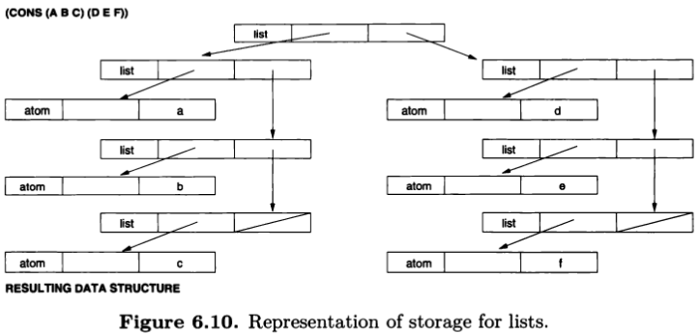

Implementation. List are not homogeneous, regular storage management useful for vectors/arrays will not work. A linked-list storage management organization is typically used. A list item is the primitive element and usually consists of a fixed-size data object. For LISP, we usually need three fields of information: a type field and two list pointers.
If the type field says atom, then the remaining fields are descriptors describing the atom.
If the type field is a list, then the first pointer is the head of the list (its first member), whereas the second is the tail of the list (its remaining members). Figure 6.10 describes the storage structure : (cons '(abc) '(def)) = ((a b c) def).
The similarity between the middle and bottom structures in Figure 6.10 shows the efficiency of this implementation for list structures:
1. Cons: cons operation is creating a new listnode and making the head field the first argument, tail field the second argument.
2. head. The head of a list is the contents (r-value) of the head field of the list item.
3. tail. The tail of a list is the contents of the tail field of the list item.

Variations on Lists: Stacks and queues, Trees, Directed graphs, Property lists (record with a varying number of components).

Sets: A set is a data object containing an unordered collection of distinct values.
A list is an ordered collection of values, some of which may be repeated.
The following are the basic operations on sets:
1. Membership. Is data value X a member of set S (i.e., is X G 5)?
2. Insertion and deletion of single values. Insert data value X in set S, if it is not a member of S. Delete data value X from S if a member.
3. Union, intersection, and difference of sets. Discribe each with example.
Note that accessing of components of a set by subscript or relative position plays no part in set processing.

